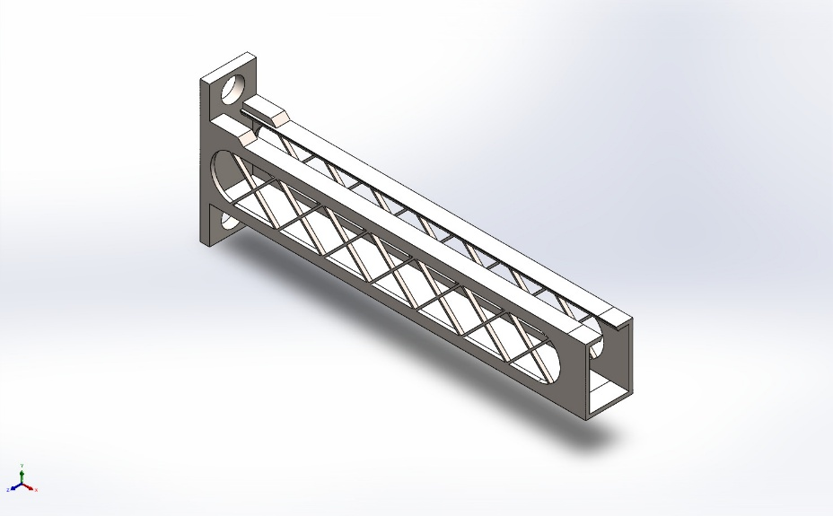
  Simulation of Cantilever Bracket
  Date: 07 June 2026
  Designer: Solidworks
  Study name: Frequency (Modal)
  Analysis type: Frequency
  Table of Contents
  Description 1
  Assumptions 2
  Model Information 2
  Study Properties 3
  Units 3
  Material Properties 4
  Loads and Fixtures 5
  Connector Definitions 6
  Interaction Information 6
  Mesh information 7
  Sensor Details 10
  Study Results 12
  Conclusion 15

Description
No Data

Assumptions

Model Information

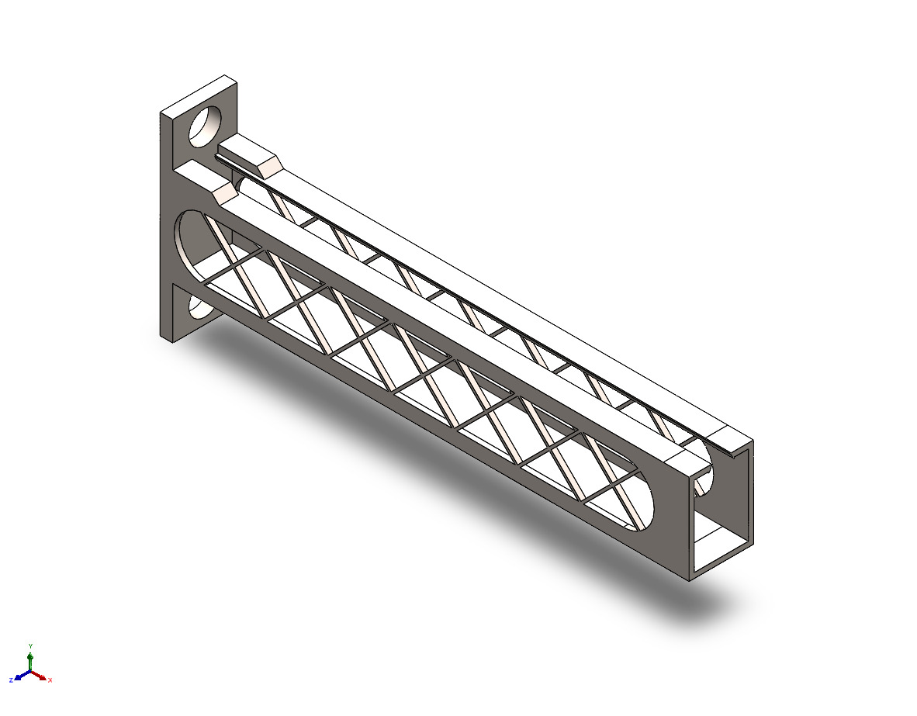
Model name: Cantilever Bracket
Current Configuration: Child Reborn
Solid Bodies
Document Name and Reference | Treated As | Volumetric Properties | Document Path/Date Modified
Mirror7  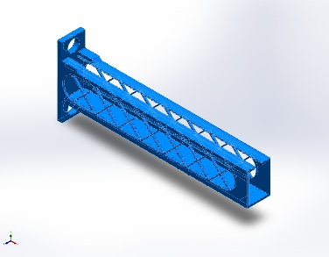 | Solid Body | Mass:269.821 kg  Volume:0.0350416 m^3  Density:7,700 kg/m^3  Weight:2,644.24 N | C:\Users\asus\Documents\Solidworks assignments\Chair\Cantilever Bracket.SLDPRT  Jun 7 10:47:26 2026

Study Properties
Study name | Frequency (Modal)
Analysis type | Frequency
Mesh type | Solid Mesh
Number of frequencies | 3
Decouple the mixed free body modes | Off
Solver type | FFEPlus
Soft Spring: | Off
Incompatible bonding options | Automatic
Thermal option | Include temperature loads
Zero strain temperature | 298 Kelvin
Include fluid pressure effects from SOLIDWORKS Flow Simulation | Off
Result folder | SOLIDWORKS document (C:\Users\asus\Documents\Solidworks assignments\Chair)

Units
Unit system: | SI (MKS)
Length/Displacement | mm
Temperature | Kelvin
Angular velocity | Rad/sec
Pressure/Stress | N/m^2

Material Properties
Model Reference | Properties | Components
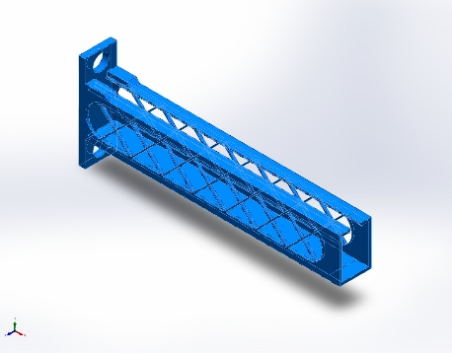 |  | SolidBody 1(Mirror7)(Cantilever Bracket)
  Name: | Alloy Steel
  Model type: | Linear Elastic Isotropic
  Default failure criterion: | Max von Mises Stress
  Yield strength: | 6.20422e+08 N/m^2
  Tensile strength: | 7.23826e+08 N/m^2
  Mass density: | 7,700 kg/m^3
  Elastic modulus: | 2.1e+11 N/m^2
  Poisson's ratio: | 0.28
  Thermal expansion coefficient: | 1.3e-05 /Kelvin
Curve Data:N/A

Loads and Fixtures
Fixture name | Fixture Image | Fixture Details
Fixed-1 | 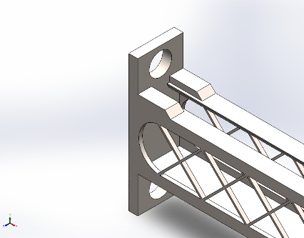
  Entities: | 1 face(s)
  Type: | Fixed Geometry

Load name | Load Image | Load Details
Force-1 | 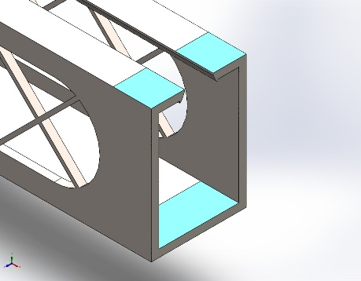
  Entities: | 3 face(s)
  Type: | Apply normal force
  Value: | 500 N
Gravity-1 | 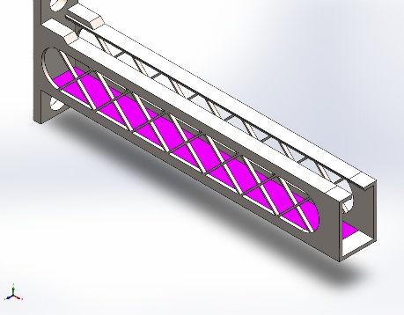
  Reference: | Face< 1 >
  Values: | 0 0 9.81
  Units: | m/s^2
Distributed Mass-1 | 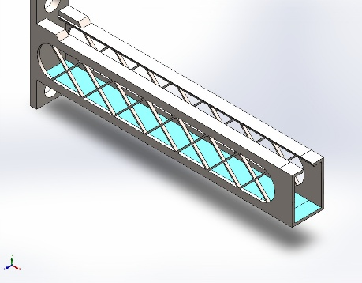
  Entities: | 2 face(s)
  Type: | Displacement (Direct transfer)
  Coordinate System: | Global cartesian coordinates
  Translation Values: | ---, ---, --- mm
  Rotation Values: | ---, ---, --- deg
  Reference coordinates: | 0 0 0 mm
  Remote Mass: | 5 kg
  Moment of Inertia: | 0,0,0,0,0,0 kg.m^2
  Components transferred: | NA

Connector Definitions
No Data

Interaction Information
No Data

Mesh information
Mesh type | Solid Mesh
Mesher Used: | Blended curvature-based mesh
Jacobian points for High quality mesh | 16 Points
Maximum element size | 275.576 mm
Minimum element size | 102.239 mm
Mesh Quality | High

Mesh information - Details
Total Nodes | 458961
Total Elements | 241739
Maximum Aspect Ratio | 9.2901
% of elements with Aspect Ratio < 3 | 95.2
Percentage of elements with Aspect Ratio > 10 | 0
Percentage of distorted elements | 0
Time to complete mesh(hh;mm;ss): | 00:00:37
Computer name:

Mesh Control Information:
Mesh Control Name | Mesh Control Image | Mesh Control Details
Control-1 | 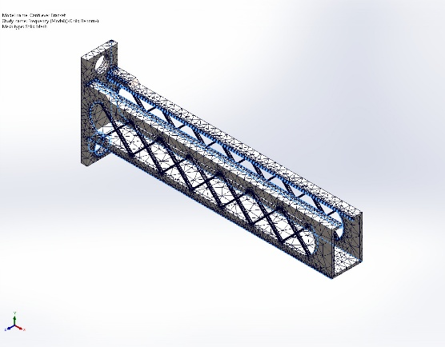
  Entities: | 25 edge(s)
  Units: | mm
  Size: | 4.8532
  Ratio: | 4.8532
Control-2 | 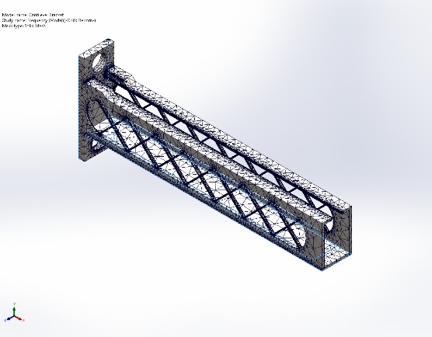
  Entities: | 23 edge(s)
  Units: | mm
  Size: | 28.5
  Ratio: | 28.5
Control-4 | 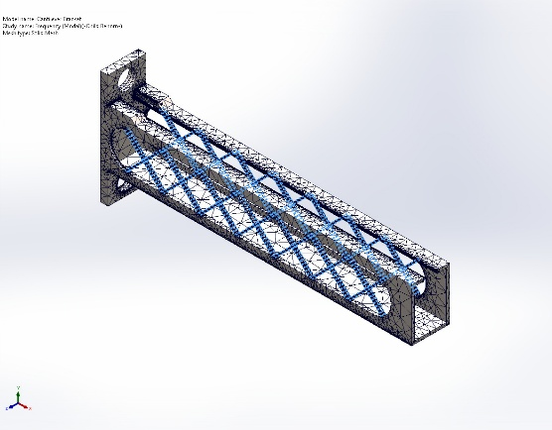
  Entities: | 224 edge(s), 1 face(s)
  Units: | mm
  Size: | 2.6846
  Ratio: | 2.6846

Mesh Quality Plots
Name | Type | Min | Max
Quality1 | Aspect Ratio | 1.016e+00  Element: 188407 | 9.290e+00  Element: 84912
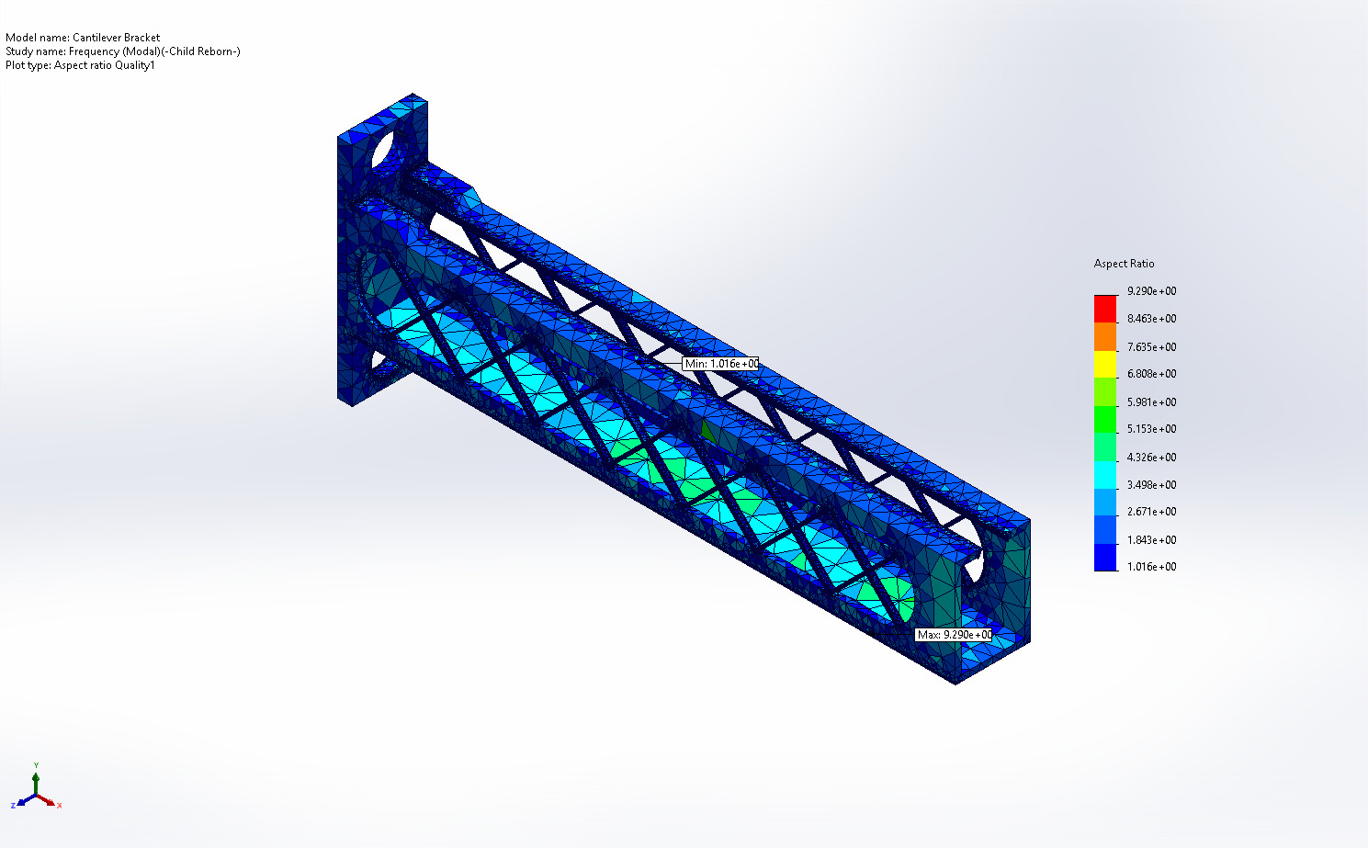
Cantilever Bracket-Frequency (Modal)-Quality-Quality1

Name | Type | Min | Max
Diagnosis2 | Mesh Quality Diagnostics : Aspect Ratio | 1.016e+00  Element: 188407 | 9.290e+00  Element: 84912
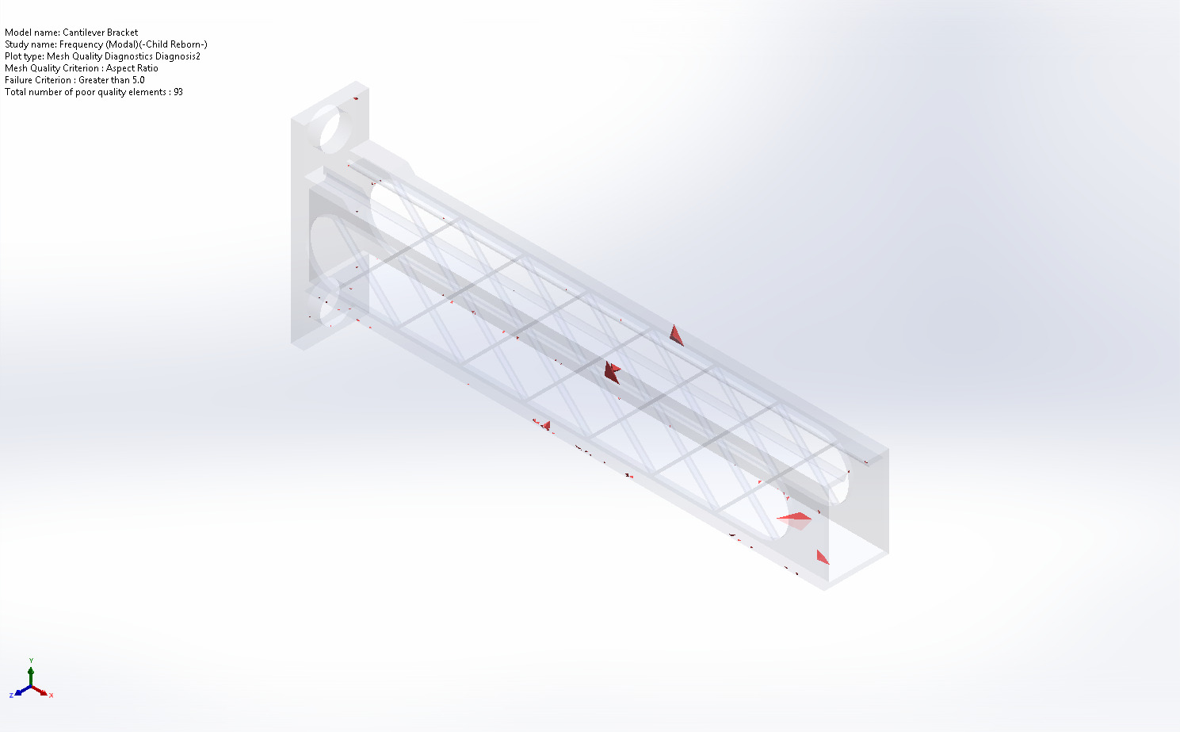
Cantilever Bracket-Frequency (Modal)-Quality-Diagnosis2

Sensor Details

Sensor name | Location | Sensor Details
Mass1 | 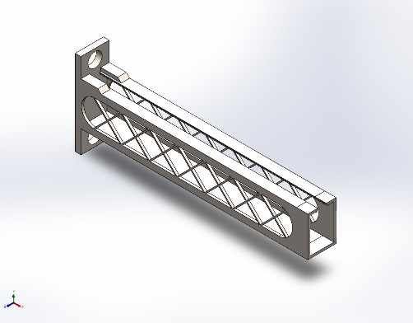 | Value : 41,695.41 g  Entities :  Result :Stress  Component :NA  Criterion :Model Max  Step Criterion : Across all Steps  Step No.:1  Alert Value: NA
Stress1 |  | Value :  Entities :  Result :Stress  Component :NA  Criterion :Model Max  Step Criterion : Across all Steps  Step No.:1  Alert Value: NA
Displacement1 |  | Value :  Entities :  Result :Displacement  Component :AMPRES: Resultant Amplitude  Criterion :Model Max  Step Criterion : Across all Steps  Step No.:1  Alert Value: NA
Mass2 |  | Value : 41,695.41 g  Entities :  Result :Stress  Component :NA  Criterion :Model Max  Step Criterion : Across all Steps  Step No.:1  Alert Value: NA
Stress2 |  | Value :  Entities :  Result :Stress  Component :NA  Criterion :Model Max  Step Criterion : Across all Steps  Step No.:1  Alert Value: NA
Displacement2 |  | Value :  Entities :  Result :Displacement  Component :AMPRES: Resultant Amplitude  Criterion :Model Max  Step Criterion : Across all Steps  Step No.:1  Alert Value: NA
Mass3 |  | Value : 41,695.41 g  Entities :  Result :Stress  Component :NA  Criterion :Model Max  Step Criterion : Across all Steps  Step No.:1  Alert Value: NA
Stress3 |  | Value :  Entities :  Result :Stress  Component :NA  Criterion :Model Max  Step Criterion : Across all Steps  Step No.:1  Alert Value: NA
Displacement3 |  | Value :  Entities :  Result :Displacement  Component :AMPRES: Resultant Amplitude  Criterion :Model Max  Step Criterion : Across all Steps  Step No.:1  Alert Value: NA

Study Results

Name | Type | Min | Max
Amplitude1 | AMPRES: Resultant Amplitude Plot for Mode Shape: 1(Value = 31.8825 Hz) | 0.000e+00  Node: 30 | 1.738e-01  Node: 113
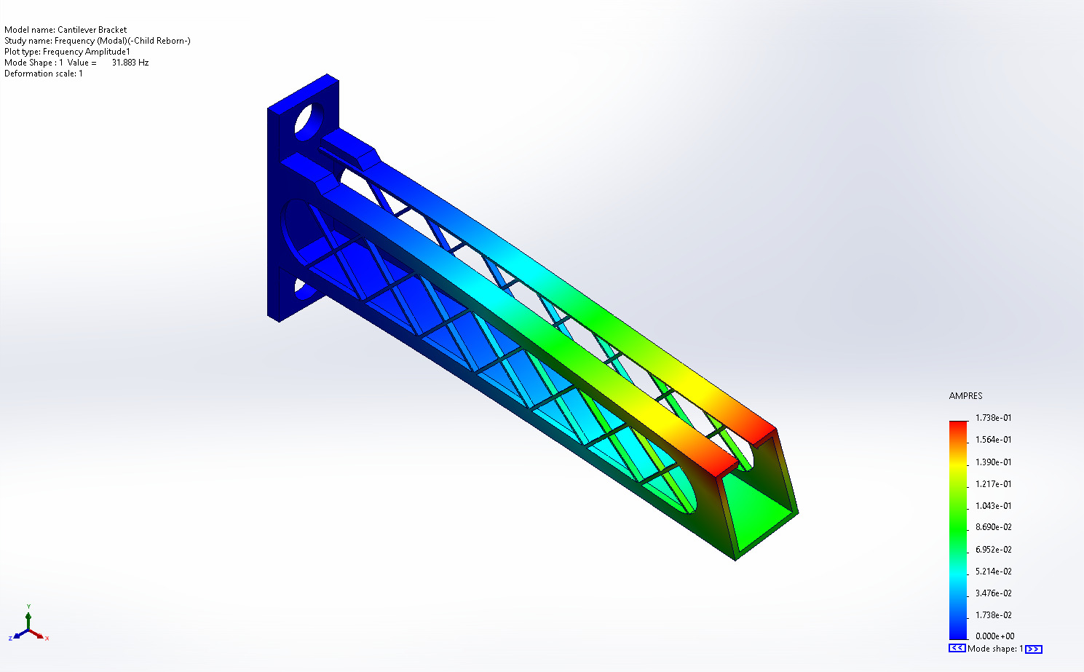
Cantilever Bracket-Frequency (Modal)-Amplitude-Amplitude1

Name | Type | Min | Max
Amplitude2 | AMPRES: Resultant Amplitude Plot for Mode Shape: 2(Value = 59.5858 Hz) | 0.000e+00  Node: 30 | 1.944e-01  Node: 361
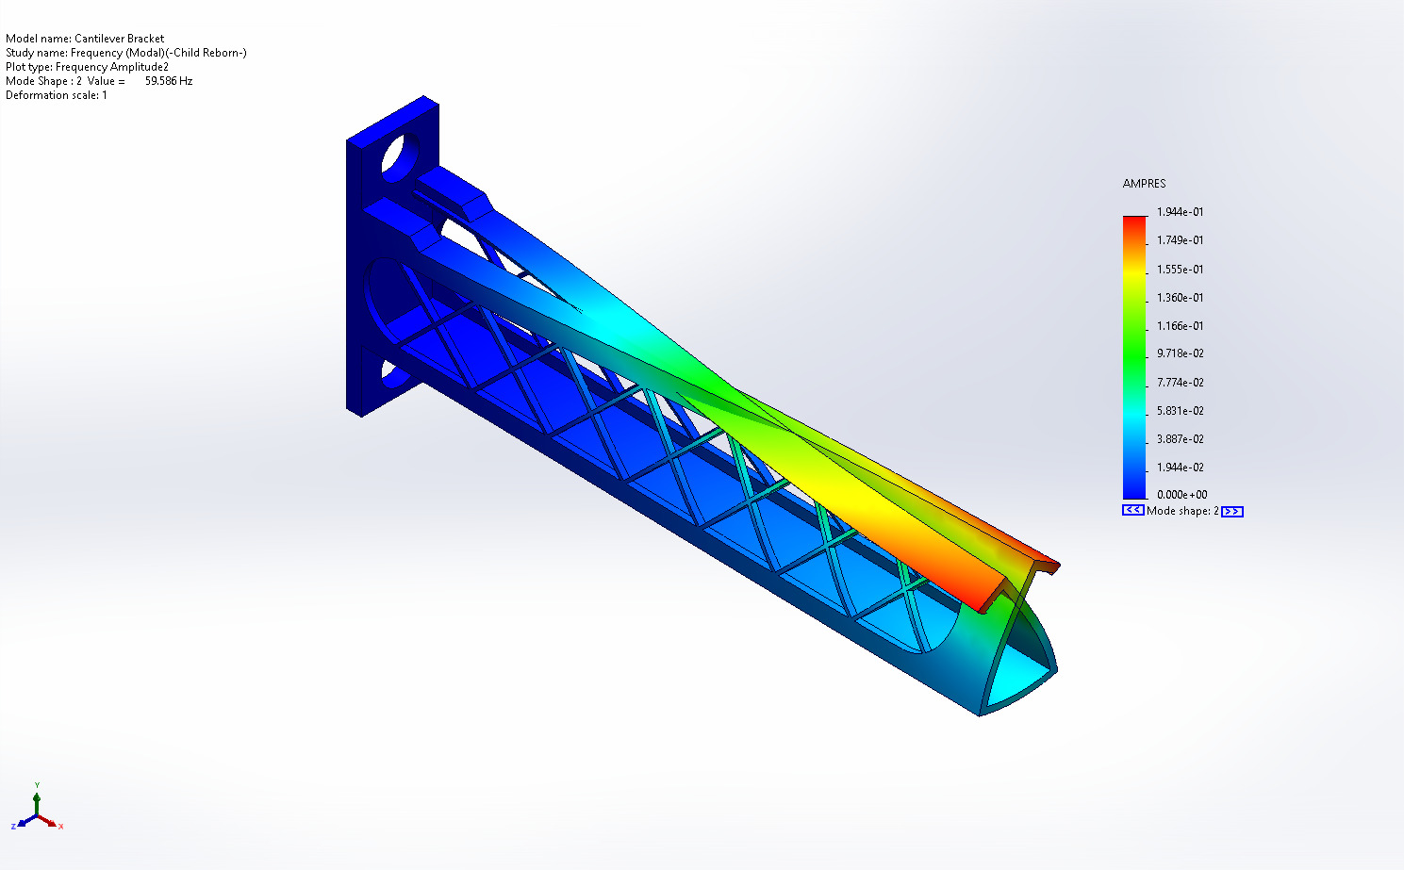
Cantilever Bracket-Frequency (Modal)-Amplitude-Amplitude2

Name | Type | Min | Max
Amplitude3 | AMPRES: Resultant Amplitude Plot for Mode Shape: 1(Value = 31.8825 Hz) | 0.000e+00  Node: 30 | 1.738e-01  Node: 113
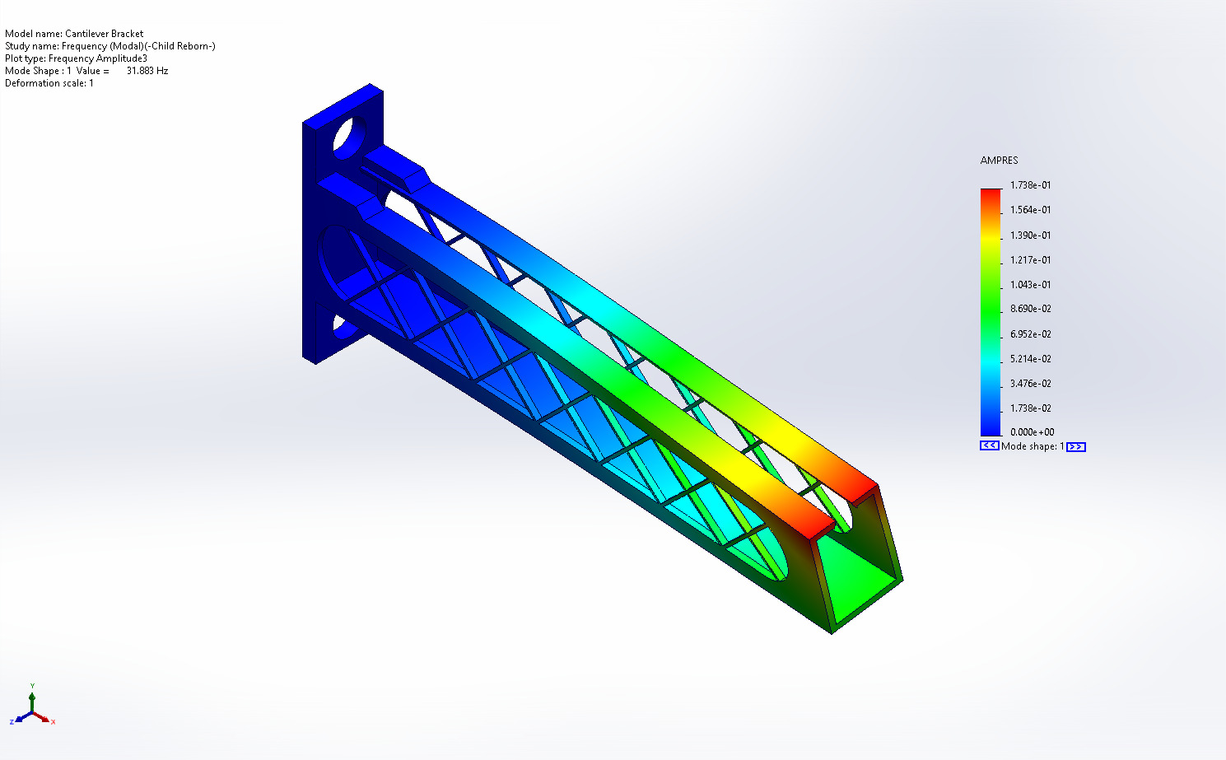
Cantilever Bracket-Frequency (Modal)-Amplitude-Amplitude3

Name | Type
Displacement1 | Deformed shape
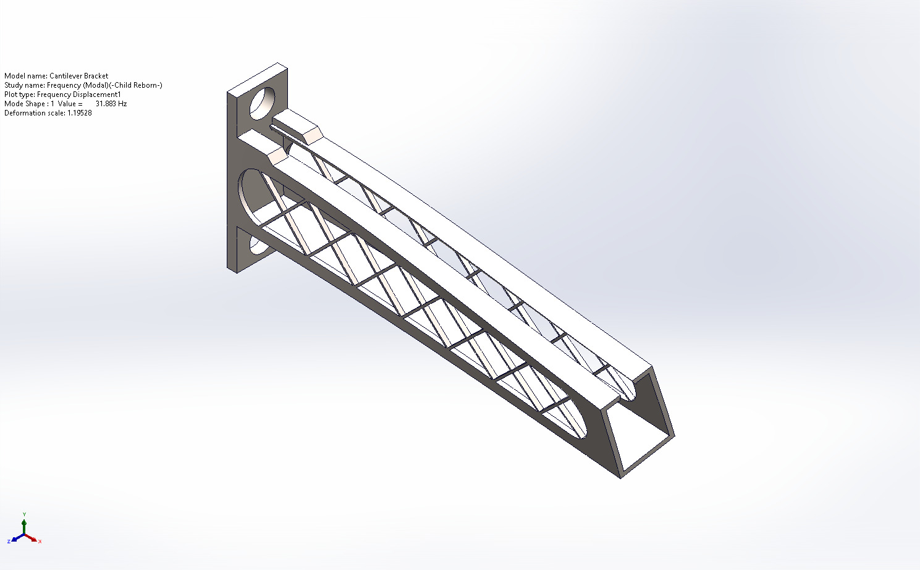
Cantilever Bracket-Frequency (Modal)-Displacement-Displacement1

Mode List
Frequency Number | Rad/sec | Hertz | Seconds
1 | 200.32 | 31.883 | 0.031365
2 | 374.39 | 59.586 | 0.016783
3 | 514.63 | 81.906 | 0.012209

Mass Participation (Normalized)
Mode Number | Frequency(Hertz) | X direction | Y direction | Z direction
1 | 31.883 | 1.1674e-11 | 5.6351e-12 | 0.41558
2 | 59.586 | 9.0083e-08 | 0.088419 | 1.4533e-08
3 | 81.906 | 3.9194e-05 | 0.41751 | 4.5231e-09
 |  | Sum X = 3.9284e-05 | Sum Y = 0.50593 | Sum Z = 0.41558

Conclusion

